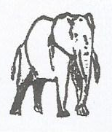
P710/2A

TECHNICAL DRAWING
GEOMETRICAL AND MECHANICAL DRAWING
Paper 2
MONDAY, 19th August 2019 (Afternoon)
3 hours

ACHOLI SECONDARY SCHOOLS EXAMINATIONS COMMITTEE
Uganda Advanced Certificate of Education
Joint Mock Examinations, 2019
TECHNICAL DRAWING
GEOMETRICAL AND MECHANICAL DRAWING
Paper 2A
3 hours
INSTRUCTIONS TO CANDIDATES:

- This paper consists of sections: A and B.
- Answer ONE question from section A and ONE question from section B.
- Not more than 25 minutes may be taken in section A.
- All measurements are in millimeters and drawings are not to scale.
- You are provided with an A2 size paper.
- Make a suitable block to indicate your name and other relevant information.

SECTION A (20 marks)
Attempt only ONE question from this section

- An involute gear wheel has the following data:
Teeth = 25
Module = 10
Angle = 20°
- Derive relevant data for the gear wheel above. (05 marks)
- Using the derived data, construct four involute spur gear teeth. (15 marks)

- Make free-hand sketches of the following.
(i) Lever and shaft showing a tapered cotter. (04 marks)
(ii) Poppet valve showing split cotter. (04 marks)
(iii) Locking plate showing set screw. (04 marks)

- Sketch the following thread profiles.
(i) Buttress (02 marks)
(ii) Acme (02 marks)
(iii) Metric thread (02 marks)
(iv) Square (02 marks)

SECTION B (60 marks)

- Figure 1 below shows parts of a LEVER.

(a) Draw a sectional front elevation of the assembly on the cutting plane A – A. (30 marks)
(b) Project the plan of the assembly in first angle projection. (11 marks)
(c) Project the end view of the assembly. (09 marks)
(d) Include any five dimensions of a varied nature. (05 marks)
(e) (i) Print your details on the standard title block. (03 marks)
(ii) Indicate projection symbol. (02 marks)

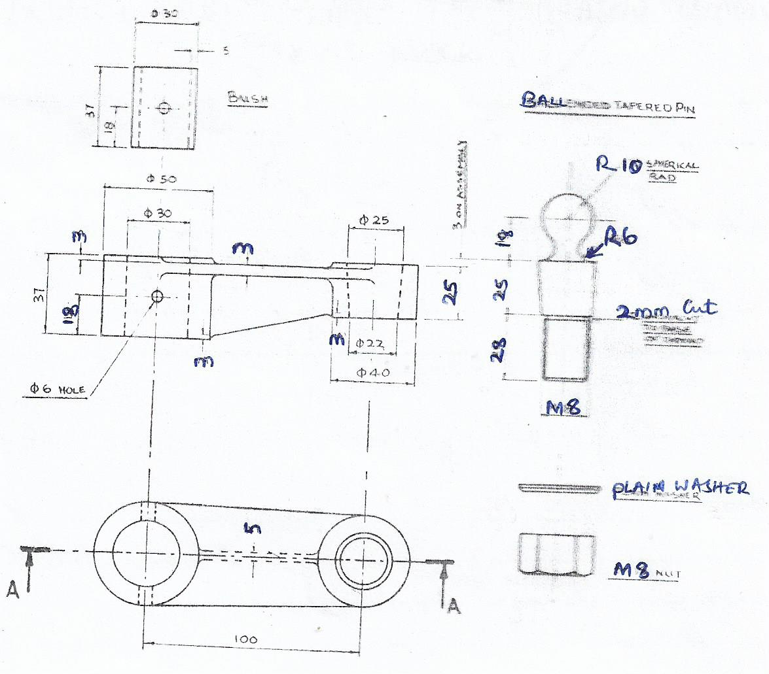

The End.

