610/1/2/3 Inst. Sch.
INSTRUCTIONS
FOR FINE ART
Paper 1/2/3
Jul/Aug 2016
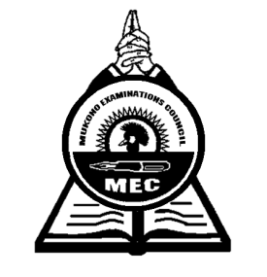

MUKONO EXAMINATIONS COUNCIL
Uganda Certificate of Education
ART CONFIDENTIALS
Paper 1, 2 & 3

Note:
Great care should be taken that the information given below does not reach the candidates either directly or indirectly.

INSTRUCTIONS FOR PREPARING THE ITEMS
The information given here is only to facilitate the preparation of the examination.

THE Head teacher should make sure that the teacher responsible for preparing items gets all items before the examination.

Paper 1 (610/1)
- One meter plain piece of cloth
- Stick of approx. 75cm in length
- One litre cylindrical tin
- Plant with three leaves and two large flowers in bright colours
- Two large balloons
- 2 large cards
- Medium size sauce pan
- A large ripe Pineapple with its head intact.
- A large water melon.
- A large sieve with a handle
- Two large oranges
- A large mature termite
- A Path, a building, some vegetation
- Aloe vera plant (Kigaji)

Paper 2 (610/2)
- A model
- A vest
- Pair of shorts
- A low traditional three legged stool (approximately 30cm high)
- A walking stick
- A short sleeved shirt / blouse
- A chair
- A table
- A large book (approx. 42cm wide when opened, 30cm long and spine is 4cm)
- A pen.

Paper 3 (610/3)
- Letrasets
- Plain white bond papers
- Rulers
- Coloured inks, pens, rubbers, strings, junk wire, paints, Markers etc
- Lino Blocks
- Sponge
- Pair of compass

End -

