P245/3
CHRISTIAN RELIGIOUS
EDUCATION
Paper 3
Jul / Aug 2016
2 ½ Hours

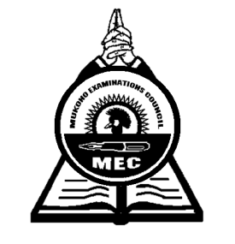

MUKONO EXAMINATIONS COUNCIL
Uganda Advanced Certificate of Education
CHRISTIAN RELIGIOUS EDUCATION
Paper 3
2 Hours 30 Minutes

INSTRUCTIONS TO CANDIDATES
- Answer any four questions

- Discuss the major features of the African Traditional Religion in the pre-colonial Era.
(25marks)
- a) How were the young at puberty stage initiated in African Traditional Society?
(12marks)
b) What were the values of initiation in any one society you know of? (13marks)
3. a) Illustrate what was taught during sex education in African Traditional Society.
(13marks)
b) Why do most parents today oppose the use of mass media as a method of sex
education? (12marks)
4. a) “Women in African Traditional Society had an inferior position.” Comment.
(15marks)
b) Explain the government effort in the promotion of women status in Uganda today.
(10marks)
5. Assess the impact of missionary activities while in East Africa. (25marks)
6. Assess the contribution of Canon Apollo Kivebulaya in his Church mission in East Africa.
(25marks)
7. How far did missionary Formal Education contribute to the spread of the Church in East
Africa? (25marks)
8. “Colonialism paved way to the expansion of Christianity in East Africa.” Discuss.
(25marks)
9. a) Account for the religious confusion at the court of Mwanga between 1888 – 1892.
(13marks)
b) How did the confusion hinder the growth of the church in East Africa? (12marks)
10. a) Account for the religious pluralism with in Christianity in East Africa today.
(13marks)
b) Suggest the remedies to such pluralism. (12marks)
11. a) Examine the main features of Bahai Faith. (13marks)
b) Account for the few followers of Bahai Faith in East Africa today. (12marks)

12. To what extent has mass media contributed to the spread of sexual immorality in East
Africa today? (25marks)
End -

