**273/2**

**GEOGRAPHY**

**Paper 2**

**August**

**2 ½ Hours**



**ELITE EXAMINATION BUREAU MOCK 2016**

**Uganda Certificate of Education**

GEOGRAPHY

**Paper 2**

**2 Hours 30 Minutes**

**INSTRUCTIONS TO CANDIDATES:**

* *Answer* ***four*** *questions only*
* *Choose* ***two*** *questions from part* ***I*** *and* ***two*** *from part* ***II****.*
* *In part II, only one question should be chosen from any* ***one*** *region.*
* *Any additional question(s) attempted will* ***not*** *be marked.*

**Turn Over**

**PART I: THE REST OF AFRICA**

***Answer two questions from this part***

1. a) Draw a sketch map of Africa and on it, mark and name.

(i) latitudes: Tropic of cancer and Capricorn.

(ii) Rivers: Zambezi and Niger

(iii) Vegetation zones: Equatorial, Savanna and desert (8marks)

b) Describe the characteristics of Savanna vegetation (6marks)

c) Explain the economic activities taking place in Africa’s savanna lands. (6marks)

d) Outline the problems facing landuse in African’s savanna lands.(5marks)

2. a) Draw a sketch map of Africa and on it, mark and name:

(i) Ocean currents: cold Benguela and Canary

(ii) marine fisheries: North West African and West African

(iii) Oceans: Indian and Atlantic (7marks)

b) Describe the physical conditions that have led to the development of fishing in the North West African Marine fisheries. (6marks)

c) Explain the effects of marine fishing on the environment in any one West African country. (8marks)

d) Outline the steps being taken to promote marine fishing in Africa. (4marks)

3. Study figure 1 of the Volta multi-purpose river development project and answer the questions that follow.

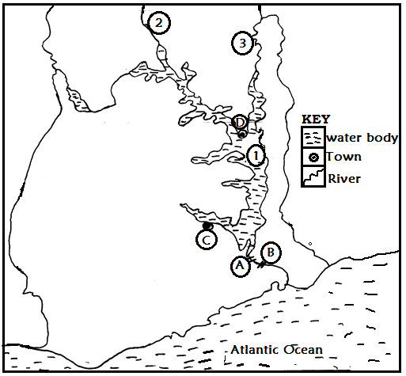

1. Name the
2. dams marked **A** and **B**
3. towns marked **C** and **D**
4. water bodies marked **1, 2** and **3** (7marks)
5. Outline the aims of the Volta multi-purpose river development project. (4marks)
6. Explain the importance of the Volta multi-purpose river development project. (6marks)
7. Outline the;
8. Problems resulting from the Volta multi-purpose river development project. (5marks)
9. Steps being taken to solve the problems in d(i) above (3marks)

4. Study table I below showing livestock population (x 1000) in 2004 in western Sahelian countries and answer the questions that follow.

**Table I: Livestock population (x 1000) in 2004 in Western Sahelian countries.**

|  |  |  |  |
| --- | --- | --- | --- |
| **Country** | **Cattle** | **Sheep** | **Goats** |
| Burkina Faso | 5,200 | 7,000 | 8,800 |
| Senegal | 3,100 | 4,700 | 4,000 |
| Mali | 7,500 | 8,364 | 12,036 |
| Niger | 2,260 | 4,500 | 6,900 |
| **Total** | **18,060** | **24,564** | **31736** |

***Adapted; by fall and Okike (2010) pp.262***

1. Draw a bar graph to represent the cattle population in 2004 in Western Sahelian countries. (7marks)
2. Identify the country with the:
3. highest, (1mark)
4. least (1 mark)

livestock population in 2004.

1. Explain the benefits of livestock rearing in any **one** western Sahelian country shown in the table. (8marks)
2. Outline the problems:
3. facing livestock rearing in Western Sahel (5marks)
4. steps being taken to improve livestock rearing in Western Sahel (3marks)

**PART II: STUDIES IN DEVELOPMENT**

Answer **two** questions from this part

**REGION I: NORTH AMERICA**

5. Study figure 2 showing the Tennessee valley area and answer the questions that follow:

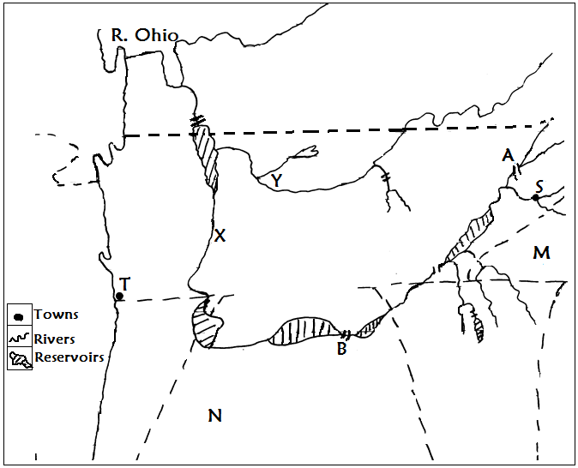  
Name the:

1. rivers marked **X** and **Y**
2. dams marked **A** and **B**
3. states marked **M** and **N**
4. towns marked **T** and **S** (8marks)
5. Describe the conditions which led to the establishment of the Tennessee Valley Authority. (6marks)
6. Explain how the Tennessee valley Authority has contributed to the modernization of the Tennessee valley area. (6marks)
7. Outline the problems that have resulted from the establishment of the project. (5marks)

6. a) Draw a sketch map of California and on it mark and name:

(i) physical divisions: central valley and coastal ranges.

(ii) rivers: Sacramento and San Joaquin

1. dams: Shasta and Hoover Dam. (7marks)

b) Describe the factors which have favoured irrigation farming in California.

(6marks)

c) Explain the effects of irrigation farming on the environment in California (8marks)

d) Outline the steps being taken to modernize irrigation farming in California

d) Explain the problems facing extensive fruit growing in California (4marks)

7. a) Draw a sketch map of New England and on it mark and name:

(i) states: Maine and Rhode Island

(ii) rivers: Hudson and penobscecot

(iii) towns; Burlington and Worcester (7marks)

b) (i) Name two industries located in any **one** town marked in a(iii) above. (2marks)

(ii) Describe the factors which have favoured the development of industries in the town chosen in b(i) above. (6marks)

c) Explain the problems resulting from industrial establishment in New England. (5marks)

d) Outline the measure being taken to overcome the problems outlined in (c) above. (5marks)

**REGION II: RINE LANDS**

8. Study figure 3: Map of Switzerland provided below and answer the questions that follow:

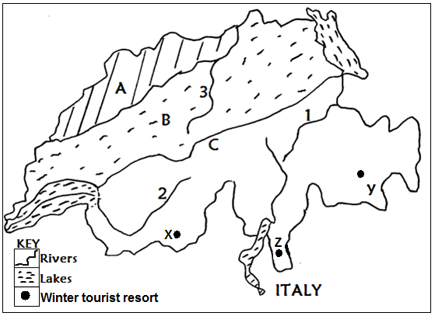

1. Name:
2. physical regions marked A, B and C
3. rivers marked 1, 2 and 3
4. winter tourist resorts marked X ,Y and Z (9marks)
5. State any two tourist activities in the winter tourist resorts of Switzerland. (3marks)
6. Describe the conditions favouring the development of tourism in the winter tourist resorts of Switzerland (7marks)
7. (i) Explain the problems facing winter tourism in Switzerland. (4marks)

(ii) Outline the measures being taken to solve the problems in d(i) above. (2marks)

9. Study table 2 below showing Netherland’s major crop exports (in 000 tones) and answer the questions that follow:

**Table II: Netherland’s major crop exports (in 000 tones)**

|  |  |
| --- | --- |
| **Type of crop** | **Exports (in 000 tones)** |
| Fruits  Vegetables  Flowers  Cereals  Sugar beets  Others | 194,000  189,000  203,000  180,000  163,000  168,000 |

***Source: 2003 African Development Indicators. World Bank***

1. Draw a line graph to represent the information given in the table above. (8marks)
2. State the:
3. highest, (1mark)
4. lowest (1mark)

crop exported to other countries.

c) Describe the conditions favouring horticulture in Netherlands. (8marks)

(i) Explain the problems facing horticulture in Netherlands (4marks)

(ii) Outline the steps that can be taken to overcome the problems in d(i) above. (3marks)

10. a) Draw a sketch map of Luxembourg and on it mark and name:

(i) rivers: Sure and Alzette

(ii) towns: Luxembourg and Wiltz

(iii) areas of high, medium and low population density (8marks)

b) Describe the conditions which have led to a high population density in the area identified in a(iii) above (8marks)

c) Explain the benefits of a high population density in Luxemburg (5marks)

d) Outline the Problems facing high population density areas in Luxembourg

(4 marks)

**REGION III: CHINA**

11. Study figure 4 below showing the Sikiang (Xijiang) River Basin and answer the questions that follow.

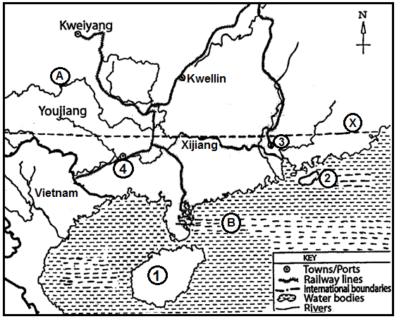

1. Name:
2. water bodies marked A and B
3. islands marked 1 and 2
4. towns marked 3 and 4
5. latitude marked X (7 marks)
6. Describe the physical conditions that favoured farming in the sikiang River Basin. (8marks)
7. Explain the effects of farming in the sikiang River Basin (5marks)
8. (i) Outline the;
9. Problems facing farmers in the sikiang River Basin (3marks)
10. Measures being taken to solve the problems in a (i) above. (2 marks)

12. a) Draw a sketch map of China and on it mark and name:

(i) sea Ports: Hong Kong, Shanghai and Qingdao

(ii) rivers: Yangtze and Sikiang

(iii) seas: East China and yellow. (7marks)

b) Describe the conditions that favoured the growth and development of any one sea port in a(i) above. (6marks)

c) Explain the benefits of the seaport chosen in (b) above to the people of china. (6marks)

d) Outline the:

(i) Problems facing seaports in China (4marks)

(ii) Steps that have been taken to solve the problems in d(i) above (2marks)

13. Study table III below showing population statistics of China’s selected largest cities in 2000 (in millions) and answer the questions that follow:

**Population statistics of China’s selected largest cities in 2000 (in millions)**

|  |  |  |
| --- | --- | --- |
| Rank | City | Urban statistical Areas of City Districts |
| 1  2  3  4  5  6 | Shanghai  Beijing  Guangzhou  Wuhan  Tianjin  Shenzhen | 13.46  9.88  7.55  6.79  6.76  6.48 |
|  | Total | 50.92 |

***Adapted: China City statistical year book 2001, Quoted by Kam Wing Chan in “The Problem with China’s urban population Data” pp3***

1. Draw a bar graph to present the information contained in the table above. (10marks)
2. Calculate the percentage contribution of the population of the following cities in the table
3. Shanghai (2marks)
4. Beijing (2marks)
5. Describe the human factors that are responsible for the large population size in any one city in (b) above. (6marks)
6. Outline the benefits of a large population size in China (5 marks)

**END**