**535/3**

**PHYSICS**

**Paper 3**

**August**

**2 ¼ Hours**

+

**ELITE EXAMINATION BUREAU MOCK 2016**

**Uganda Certificate of Education**

Physics Practical

**Paper 3**

2 hours 15 minutes

**Instructions to the Candidates:**

* *Answer question 1 and one other question.*
* *You are not allowed to start working with apparatus for the first 15 minutes.*
* *Marks are given mainly for a clear record of observations actually made, for their suitability, accuracy and for the use made of them.*
* *Candidates are reminded to record their observations as soon as they are made.*
* *Whenever possible, candidates should put their observations and calculations in a suitable table drawn in advance.*
* *An account of the method of carrying out the experiment is not required.*
* *Squared papers are provided.*
* *Mathematical tables are provided, silent non-programmable calculators may be used.*

**Turn Over**

1. **In this experiment, you will determine the force constant, K, of a spiral spring provided**. **(20marks)**

**PART ONE**

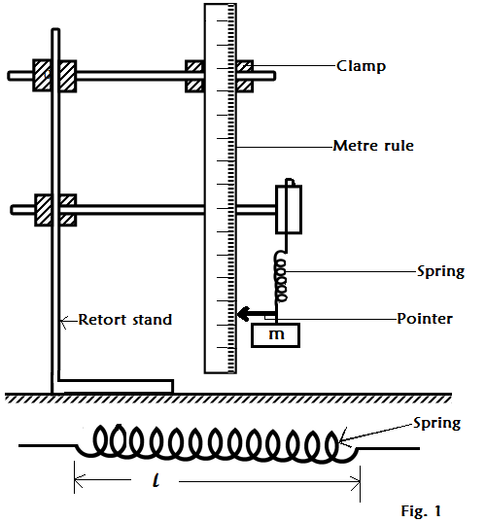

1. Measure and record the length, $l$, of the spring in metres.
2. Record the number of turns, N, of the spring.
3. Clamp the metre rule and the spring as shown in figure one.
4. Read and record the position, **Po**, on the metre rule.
5. Suspend a mass, **m** equal to 0.100kg on the spring.
6. Read and record the new position, **P** of the pointer on the metre rule.
7. Find the extension, e in metres
8. Find K1 from the expression.

$$K_{1}= \left[\frac{10m}{e} + {\left(\frac{l}{N}\right)}^{\frac{1}{2} }\right]$$

**PART TWO**

1. Arrange the apparatus as shown in figure one.
2. Read and record the position of the pointer **Xo** on the metre rule.
3. Suspend a mass, **m** = 0.100kg on the spring in metres.
4. Read and record the new position, **X1** of the pointer on the metre rule.
5. Find the extension, **X** of the spring in metres.
6. Pull the mass slightly and release it to make vertical oscillations
7. Measure and record the time, **t** for **20** oscillations.
8. Find the periodic time, **T** for one oscillation.
9. Repeat procedures (d) to (h) for values of **m** = 0.300, 0.400, 0.500, 0.600 and 0.700kg.
10. Record your results in a suitable table including values of **T2** and **f** where, **f** is the frequency.
11. Plot a graph of **m** (along the vertical axis) against X (along horizontal axis).
12. Determine the slope, **K2**, of the graph.
13. Find the constant, **K** of the spring from;

$K=\frac{1}{2}\left(K_{1}+ K_{2}\right)$

**2. In this experiment, you will determine the focal length, f of a converging lens** **labelled L.** **(2omarks)**

**PART ONE**

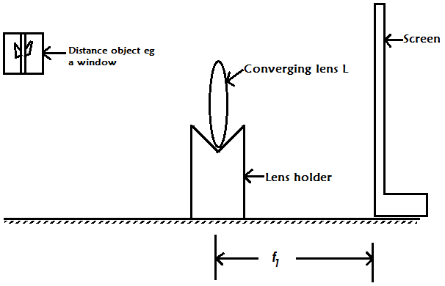

1. Mount the lens, L in a lens holder and focus it to a nearby object
2. Move the screen to and fro until when a clear image of the distant object is formed on it.
3. Determine the distance, **f1**

**PART TWO**

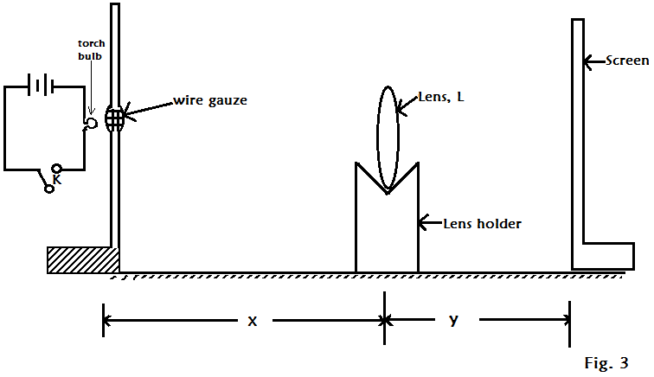

1. Arrange the torch bulb, wire gauze, lens L and the screen as shown in figure 3.
2. Adjust the distance **X = f1**
3. Close switch K.
4. Adjust the position of the screen to obtain a sharp image of wire gauze on the screen.
5. Open switch K.
6. Measure the distance, y of the screen from the lens L.
7. Repeat procedures (b) to (f) for values of **x = 1.5f1, 2f1, 2.5f1, 3f1, 3.5f1** and **4f1.**
8. Record your results in a suitable table including values of $xy, x+y, \frac{1}{x} and \frac{1}{y}$
9. Plot a graph of $\frac{1}{y} \left(along the vertical axis\right)against\frac{1}{x} (along the horizontal axis)$.
10. Determine the intercepts, ${X }_{1}$ and $Y_{1}$ on the $\frac{1 }{X}$ and $\frac{1}{y}$ axes of your graph.
11. Find the focal length, $f_{2}$, $from, f_{2}=\frac{1}{2}\left(\frac{1}{x_{1}}+ \frac{1}{y_{1}}\right)$
12. Determine the focal length, f, of lens L from the expression.

3. **In this experiment, you will determine the resistance R of the material of a bicycle spoke provided. (20marks)**

**PART ONE**

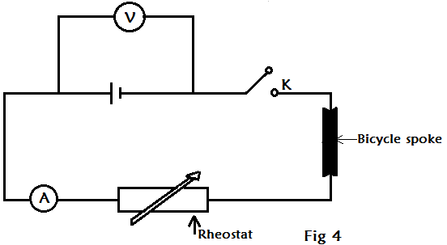

1. Connect the circuit with the bicycle spoke as shown in figure 4.
2. With switch, K, open read and record the voltmeter reading, **Vo**.
3. Close the switch, K and adjust the rheostat so that the reading, **I** on the ammeter is 0.20A.
4. Read and record the voltmeter reading, **V1**
5. Open switch K.
6. Find the value of, V from **V = $\left(V_{1}- V_{o}\right)$,** hence find R from, $R= \frac{V}{I}$.

**PART TWO**

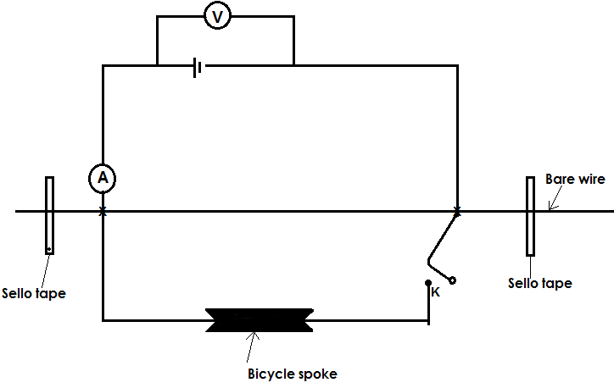

1. Connect the circuit as shown in figure 5 starting with a length **x = 0.200m**
2. Close switch K.
3. Read and record the ammeter and voltmeter readings **I** and **V** respectively.
4. Open switch K.
5. Repeat procedure from (b) to (d) for values of **x = 0.300, 0.400, 0.500, 0.600** **and 0.700m.**
6. Record your results in a suitable table including values of $\frac{V}{I}$.
7. Plot a graph of $\frac{V}{I}$ against x.
8. Find the slope, **S** of the graph
9. Calculate, **R** from **R = SXr**, where **Xr = 1.000m.**

**END**