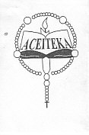

314 / B / SE / OE
FRENCH
PAPER 1
SPOKEN EXPRESSION
20 MINUTES

ACEITEKA JOINT MOCK EXAMINATION 2016
Uganda certificate of education
FRENCH
PAPER 1B
Look carefully at this picture for 10 minutes . Then , describe it orally in at least 10 sentences . You are advised to avoid repeating the same expression . Credit will be given for well-developed sentences.
